Contractual Date of Delivery to the EC:
Actual Date of Delivery to the EC:
Workpackage: | WP 4.1.
Author(s) and Institutions | Jan Nemrava (UEP), Ondřej Šváb (UEP), Mirek Vacura (UEP), Herwig Zeiner (Joanneum)
Estimated Staff Months:
Dissemination Level:
Nature: | Report
Approval Status:
Version: | V1.0
Total Number of Pages: | 17
Filename:
Keyword list: | Annotation tools survey, MPE7 descriptors,
Abstract
Annotation tools survey considering both multimedia and textual documents. All available tools are described + compared according to given criteria.

Table of Contents

1. Table of Contents 2
2. History 4
3. Authors 5
4. Labelling tools 6
4.1. General Requirements 6
4.2. K-Space Requirements 6
4.3. Useful and unique features 6
4.4. Comparison method 6
5. Video/Audio and Image 7
5.1. IBM MPEG-7 Annotation Tool (IBM) 7
5.2. COALA: Content-Oriented Audiovisual Library Access (EPFL) 7
5.3. Mdéfi – (INRIA) 8
5.4. VIDETO – (ZGDV) 10
5.5. Ricoh 10
5.6. Annotation GAMP, PrestoSpace (JRS) 11
5.6.1. Features 11
5.6.2. Screenshots 14
5.7. Production Tools (NM2), JRS 15
5.8. PhotoStuff (Mindswap) 15
5.9. flickr2rdf 16
5.11. LabelMe 17
6. Text 18
6.1. OntoMat (AIFB) 18
6.2. SMORE (Mindswap) 18
6.3. Annotea 18
6.4. Ontogloss 20
7. Feature Extraction Tools 20
7.1. M-OntoMat-Annotizer (ITI-CERTH and Koblenz) 20
8. Special 21
8.1. Biology 21
8.1.1. ZFIN Image Annotation Tool 21
8.2. Medicine 21
8.2.1. Stepper 21
9. Conclusion 21
10. Comparison Table 22

History

Version | Date | Reason | Revised by
01 | 26/05/06 |  | Nemrava J.

Authors

Partner | Name | Phone / Fax / Email
UEP | Nemrava Jan | nemrava@vse.cz
UEP | Šváb Ondřej | svabo@vse.cz
UEP | Vacura Mirek | vacuram@vse.cz
Joanneum | Herwig Zeiner | herwig.zeiner@joanneum.at

Labelling tools

General Requirements

K-Space Requirements

Useful and unique features

Comparison method
Features to be compared (see attached Excel file)

Platform & Language
Feature Extraction / Annotation Tool
Subject of annotation
Available for Download
Licence
Open Source
Commercial
Import Ontologies
OWL
DAML+OIL
RDFS
Result
RDF
N3
XML
MPEG7 Descriptors
Still Under development
Developed by KSpace partner
Last Update

Video/Audio and Image

IBM MPEG-7 Annotation Tool (IBM)
IBM MPEG-7 Annotation Tool [1] assists in annotating video sequences with MPEG-7 metadata. Each shot in the video sequence can be annotated with static scene descriptions, key object descriptions, event descriptions, and other lexicon sets. The annotated descriptions are associated with each video shot and are put out and stored as MPEG-7 descriptions in an XML file. IBM MPEG-7 Annotation Tool can also open MPEG-7 files in order to display the annotations for the corresponding video sequence. IBM MPEG-7 Annotation Tool also allows customized lexicons to be created, saved and downloaded. Support for both MPEG-1 and MPEG-2 files as well as regional annotations. It also comes with a shot detection algorithm, an easy-to-use interface and a customisable lexicon. Provided that a video has a different format then it cannot be displayed correctly. The lexicon is also restricted to three default categories (event, static scene and key objects), although free text keywords can also be added. IBM’s system doesn’t support hierarchical video segmentation [2]

It is the only freely available tool that can be directly downloaded that we have encountered. It takes MPG videos as input and MPG7 W3C XML Schema as a list of instances. It provides annotations for video shots and allows exporting it in MPG7 W3C XML Schema. Availability to create new classes of events, static scenes and key objects and export them into MPG7 Schema.

[1] Downloaded from http://www.alphaworks.ibm.com/tech/videoannex
[2] Schroeter R, Hunter J, Kosovi D.: FilmEd – Collaborative Video Indexing, Annotation and Discussion Tools Over Broadband Networks, http://metadata.net/filmed/pub/MMM04_FilmEd.pdf

COALA: Content-Oriented Audiovisual Library Access (EPFL)
The aim of the project [1] is to design and implement a digital audio-visual library system for TV broadcasters and video archive owners with facilities to provide effective content-oriented access to internal and external
Basic Features:
- semantic model for the retrieval of audiovisual information: Semantic Views Model
- high-level query language following the Semantic Views Model, called Semantic Views Query Language (SVQL)
- TVN Schema, a TV news description schema based on MPEG-7, which allows the representation of TV news information in an environment that integrates the three processes of production, archiving,

No downloadable file, questions without response.

[1] Swiss Federal Institute of Technology (EPFL). COALA (Content-Oriented Audiovisual Library Access) – LogCreator. http://coala.epfl.ch/demos/demosFrameset.html

Mdéfi – (INRIA)
Mdéfi (Multimedia DEscription and Fine-grained Integration) is toolset for temporal and spatial organisation of multimedia documents using internal relations. Using Mdéfi it is possible to describe internal structure of complex multimedia (i.e. video) documents. It also permits user to temporaly and spatially synchronize video and text, images or amother media.

Mdéfi utilises Madeus, the multimedia description language based on XML [3] developed as part of Madeus Enviroment [1] in OPERA project [2], that enables use of MPEG-7 multimedia descriptors.

Mdéfi is based on thesis by Tien Tran Thuhong [4] and is not available for download, yet there are some demo videos on authors web page [5].

No downloadable file

[1] Jourdan (M.), Laya ida (N.), Roisin (C.), Sabry-Ismail (L.), Tardif (L.), "Madeus, an Authoring Environment for Interactive Multimedia Documents", 6th ACM Multimedia '98, Bristol, 12-16 septembre 1998.
http://citeseer.ist.psu.edu/jourdan98madeus.html

[2] http://opera.inrialpes.fr/OPERA/

[3] T. Tran_Thuong, C. Roisin. A Multimedia Model Based on Structured Media and Sub-elements for Complex Multimedia Authoring And Presentation. Special Issue on "Image and Video Coding and Indexing", Int'l Journal of Software Engineering and Knowledge Engineering, 2002.
http://opera.inrialpes.fr/people/Tien.Tran-Thuong/Publations/Journals/IVCI_F
inalLastVersion290502.pdf

[4] T. Tran_Thuong, Media content modelling and processing for authoring and presenting multimedia documents. Institut National Polytechnique de Grenoble (PhD thesis), February 2003, Grenoble, France.
http://opera.inrialpes.fr/people/Tien.Tran-Thuong/Publations/These/TheseV8PD
F.pdf

[5] http://opera.inrialpes.fr/people/Tien.Tran-Thuong/Welcome.html

VIDETO – (ZGDV)

Videto [1] is designed to easily generate application specific video descriptions. VIDETO is designed to facilitate the creation of MPEG-7 descriptions but supports different data output formats. MPEG-7 descriptions are considerably complex and therefore require profound knowledge of the standard during the metadata generation process. It is an easy-to-use tool for annotating video and video segments. It can be used even by nonexperts to create professional description data like MPEG7. It provides automatic scene boundary detection and extraction of key frames with optional manual verification and correction.

No response from ZGDV. No functional copy could be obtained.
[1] Zentrum fuer Graphische Datenverarbeitung e.V. (ZGDV). VIDETO - Video Description Tool. http://www.rostock.zgdv.de/ZGDV/Abteilungen/zr2/Produkte/videto/index_html_en

Ricoh
Ricoh MovieTool is a tool for creating video content descriptions conforming to MPEG-7 syntax interactively. It is intended for use by researchers and designers of MPEG-7 applications. MovieTool generates MPEG-7 descriptions based on the structure of a video. A major advantage to using MovieTool is that the user can quickly and easily see the correspondence between the MPEG-7 descriptions and the video structure of each scene. Explanatory descriptions can be added for each scene and become part of the MPEG-7 file. The MPEG-7 file can then be used, for example, to search for or jump directly to specific scenes [1]
Ricoh's MovieTool does support hierarchical segmentation within a timeline-based representation of the video. The automatic shot boundary detection algorithm permits changes to threshold settings. The MovieTool is the most mature and complete of the systems, but has a complicated user interface which is closely tied to the MPEG-7 specification. The user has to have a good knowledge of the large and komplex XML Schema definition of MPEG-7 in order to browse using the MPEG-7 Editor [2]

[1] http://www.ricoh.co.jp/src/multimedia/MovieTool/
[2] Schroeter R, Hunter J, Kosovi D.: FilmEd – Collaborative Video Indexing, Annotation and Discussion Tools Over Broadband Networks, http://metadata.net/filmed/pub/MMM04_FilmEd.pdf

Annotation GAMP, PrestoSpace (JRS)
Contribution by Zeiner, Herwig, Joanneum (herwig.zeiner@joanneum.at):
The Annotation GAMP is a component of the MAD Documentation Platform. It has the following functionalities:
- validation and correction of automatic content analysis results
- structuring of the content according to semantics
- textual annotation on different structural levels of the content (programme, scene, shot, arbitrary temporal range)
This section collects the requirements and functionalities concerning the following issues:
- Which audio-visuell content analysis results shall be visualized / edited?
- Which semantic analysis results shall be visualized / edited?
- Which additional manual annotation functionalities shall be available?

Features
The following table list the results of audiovisual content analysis and semantic analysis that shall be visualized and/or edited. The visualization and the possible user interactions for editing the results are also included in the table.

Multimedia Object (MMO) | unit | visualisation | User interaction for editing
shot boundaries | EO → shot | Time line with cuts and gradual transitions (including type of gradual transitions, if detected) | add/delete/move shot boundary, change type of shot boundary
key frames | shot → key frame | Time line with key frame images | Add/delete key frames
stripe images | segment | Time line with stripe images | none
camera motion | segment (<= shot) | Time line with bars representing camera motion segment and type of motion (optionally amount of motion) | Add/delete motion annotation, change start/end of motion annotation
ASR | speech segment | Text box, synchronized with video | Edit text of segment
speaker identification | speech segment | Time line with bars indicating occurrence of speaker, color or text identifies recognized speaker | Add/delete occurrence, change start/end, change label (selecting from controlled vocabulary)
event / moving object / face detection/recognition | segment (<= shot) | Time line with bars representing occurrences, label indicating type, optionally object region visualized in video player | Add/delete occurrence, change start/end, change label (selecting from controlled vocabulary)
visual similarity | shot | List of links to other shots (including keyframe visualisation) | Add/remove entries
motion activity | shot | Line graph | none
audio power | segment | Line graph | none
technical metadata | Material | Text boxes, selection lists | edit/complete fields (partly using controlled vocabulary)
scene segmentation | EO → segment (story, scene) | Tree structure (optional additional time line with bars) | Add/move/delete segment, change title of segment, associate segment with shot  e.g. propagating annotations from one segment to another  - select list of shots (suggestion provided automatically)  - select subset of annotations to apply  - ideally, one could not just start with one shot and apply annotations to others, but the annotations from all visually similar shots are collected and the user can select the subset to be applied to all (potentially there may be contradictions, but they are unlikely and indicate inconsistencies in the annotation, so must be overridden)
classification | segment (e.g. EO, story, scene) | Text box/selection list for each segment of structure | Select from controlled vocabulary
occurrence of semantic entity | segment | List of entities for each segment of structure, grouped by type of entity | Add/remove entity (selecting from controlled vocabulary), change type (selecting from controlled vocabulary)
production metadata | EO | Text boxes/selection list/date control for each EO segment | edit, select partly from controlled vocabulary
related material | segment | List that is dynamically updated depending on segment | Add/remove entries from list, URLs of external data, access related web content
Table 1: Audiovisual content analysis results visualization and editing.

Screenshots

Figure 1 and Figure 2 show prototypes of an interface for manual documentation. The views in the lower part display content analysis results. Shot boundaries, key frames and camera motion segments can also be edited by the user. The component in the upper center visualizes a tree structure of the video. The user can relate user-defined segments (e.g. scenes) to automatically extracted segments (e.g. shots). The component in the upper right allows the annotation of title, content summary, actors, objects and settings related to the segment selected in the tree.
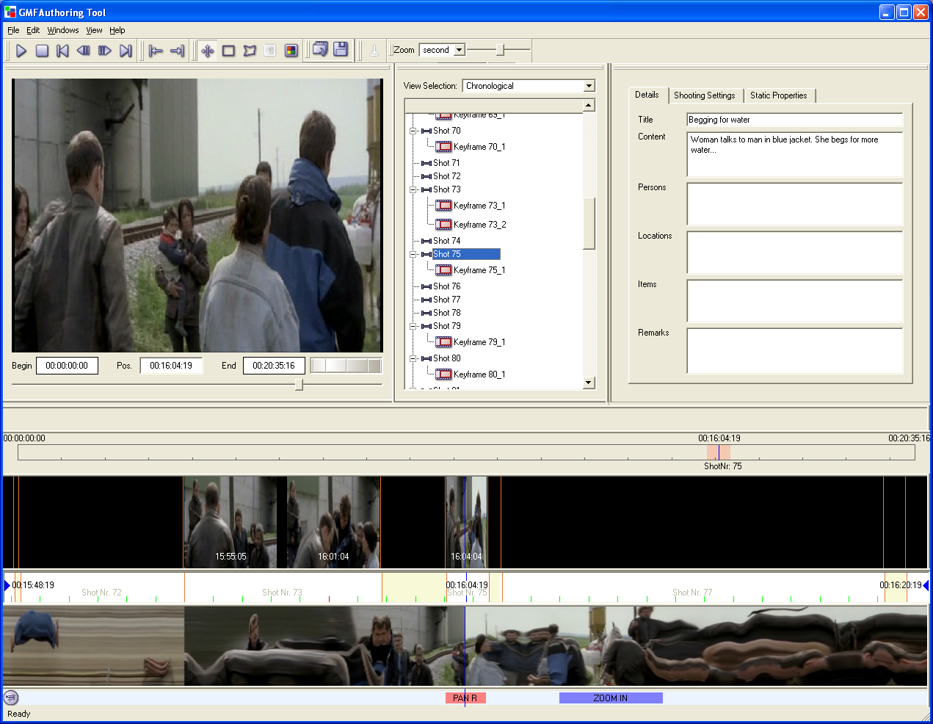
Figure 1: Study of user interface for manual documentation and structuring.
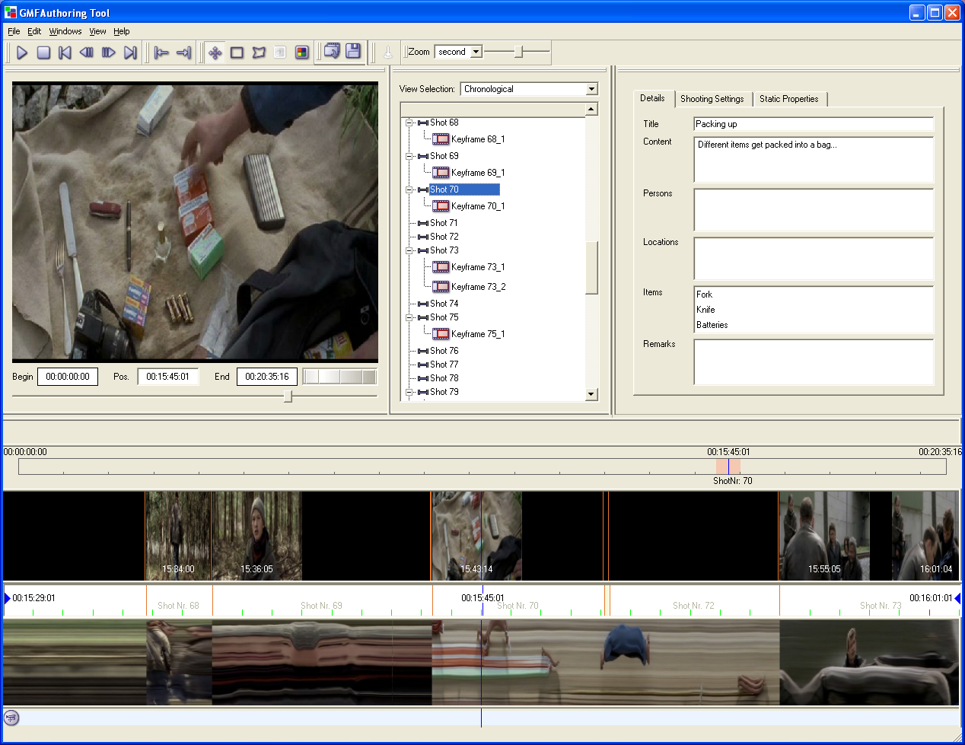
Figure 2: Study of user interface for manual documentation and structuring.

Production Tools (NM2), JRS

NM2 is developing compelling new media forms which take advantage of the unique characteristics of broadband networks. To achieve this goal NM2 will create tools for the cost efficient production of non-linear interactive narratives that are integrated with emerging end-to-end digital production environments. Using a practice-based research methodology, NM2 will deliver seven example productions.

Within the project JOANNEUM RESEARCH focuses on the production tools. The tools consist of the following components:
- The Ingestion Tool enables producers to import the essence (media files, as video-footage, audio clips, etc.) and metadata (scripts, shot-logs, EDLs, etc.) into the NM2 system.
- The Media Semantics Mapping Utility (pronounced: Monsoon) enables the definition of logical entities that may occur in the essence (cf. Section 5). The output is a knowledge base that is used in the Description Tool to (semi)-automatically markup media items.
- The Description Tool allows creating, modifying, and deleting media items. Both low-level features as well as ontology-based metadata can be 2 expressed in this tool, including automatic content analysis (performed on MPEG-7/low-level features).
- The Authoring Tool is used by the producers to create interactive narratives. Narrative objects can be placed and interconnected onto a workspace, media items from the Description Tool can be added to the workspace, and specific rules and heuristics can be entered to lay out the logic of the respective narrative.

PhotoStuff (Mindswap)
PhotoStuff is a platform independent (written in Java), image annotation tool which uses an ontology to provide the expressiveness required to assert the contents of an image, as well information about the image (date created, etc.).

PhotoStuff allows users to annotate regions of an image with respect to concepts in any ontology specified in RDFS or OWL. It provides the functionality to import images (and their embedded metadata), ontologies, instance-bases, perform markup, and export the resulting annotations to disk or a Semantic Web portal.

PhotoStuff load multiple ontologies at once, enabling a user to markup images with concepts distributed across any of the loaded ontologies. Using a variety of region drawing tools, users are able to highlight regions around portions of images (from Web and/or local disk) loaded in PhotoStuff. Classes from loaded ontologies can be dragged into any region, or into the image itself, creating a new instance of the selected class.

PhotoStuff also takes advantage of existing metadata embedded in image files (Dublin core and EXIF file) by extracting and encoding such information in RDF/XML.

(http://www.mindswap.org/2003/PhotoStuff/)

The following shouldn’t be probably compared with the previous one.

flickr2rdf
This Web-based service uses Flickr API to extract metadata from Flickr's photo repository, and generates an RDF description.Flickr is an online photo management and sharing application in which users can upload their photos and also annotate them (http://www.flickr.com/).The flick2rdf Web-based service converts mainly the tags of a flickr image metadata to FOAF (Friend of a Friend) RDF by Masahide Kanzaki.

(http://purl.org/net/kanzaki/flickr2rdf)

JpegRDF reads and manipulates RDF metadata stored in the comment section of JPEG images. It can extract, query, and augment the data. Manipulating JPEG images with jpegrdf does not modify the actual image data or any other sections of the file.Ending JpegRDF can also be used to convert EXIF to RDF.

(http://nwalsh.com/java/jpegrdf/)

LabelMe
LabelMe is a research tool for labelling objects in images. LabelMe builds a large collection of annotated images. Trace the outline of as many different objects from the image and for as many image. Annotations will become immediately available for the scientific community to be used for object recognition research

(http://people.csail.mit.edu/brussell/research/LabelMe/intro.html)

Text

OntoMat (AIFB)
OntoMat-Annotizer is an interactive webpage annotation tool. It supports creating and maintaining ontology-based OWL. It includes an ontology browser for the exploration of the ontology and instances and a HTML browser that will display the annotated parts of the text. The intended user is the individual annotator. It is planned that a future version will contain an information extraction plugin that offers a wizard which suggest which parts of the text are relevant for annotation. That aspect will help to ease the time-consuming annotation task.

http://annotation.semanticweb.org/ontomat/index.html
OntoMat description :(http://www.servogrid.org/slide/GEM/SW/Tool%20Review--OntoMat.doc)

The development was discontinued.

SMORE (Mindswap)
SMORE is designed to enable users to markup HTML documents in OWL using Web Ontologies.
- Allow the user to markup web documents with limited knowledge of OWL terms and syntax.
- Provide a way to use Classes, Properties, and Individuals from existing ontologies, do limited ontology editing, or even create a new ontology from scratch using terms from web documents.
- Provide the flexible environment to create simple web page simultaneously with markup.
(http://www.mindswap.org/2005/SMORE/)

Annotea
Annotea enhances collaboration via shared metadata based Web annotations, bookmarks, and their combinations. When the user gets the document he or she can also load the annotations attached to it from a selected annotation server or several servers and see what his peer group thinks. Annotea is open; it uses and helps to advance W3C standards when possible. It provides a RDF metadata based extendible framework for rich communication about Web pages while offering a simple annotation and bookmark user interface. The annotation metadata can be stored locally or in one or more annotation servers and presented to the user by a client capable of understanding this metadata and capable of interacting with an annotation server with the HTTP service protocol.

(http://www.w3.org/2001/Annotea/)

Ontogloss
OntoGloss is an ontology based annotation tool that uses pre–defined concepts in ontology to mark–up a document
- Using different ontologies to mark-up documents, paragraphs, sentences, words and morphemes. It is independent of the selected ontology and can accommodate several ontologies at thE same time.
- Annotating the document with drag and drop operation. Moving the mouse over an annotated selection, linguist can see the type of annotation.
- Automatically annotating new documents based on the previously annotated documents.
- Exporting annotation data into RDF format. RDF data can be loaded into an RDF repository like Sesame with querying capabilities.
- Keeping annotation separate from the actual document. Annotated data is saved in a database and is loaded during each visit to the document.
- Annotating the whole document with general information like the name of the annotator, date and other information as specified in the Dublin Core.

OntoGloss Introduction: http://emeld.org/workshop/2005/papers/mostowfi-paper.html

Feature Extraction Tools

M-OntoMat-Annotizer (ITI-CERTH and Koblenz)
(M stands for Multimedia) is a user-friendly tool developed inside the aceMedia project that allows the semantic annotation of images and videos for multimedia analysis and retrieval. It is an extension of the CREAM (CREAting Metadata for the Semantic Web) framework and its reference implementation, OntoMat-Annotizer. The Visual Descriptor Extraction Tool (VDE) was developed as a plug-in to OntoMat-Annotizer and is the core component for extending its capabilities and supporting the initialization and linking of RDF(S) domain ontologies with low-level MPEG-7 visual descriptors. It’s purpose is to annotate videos for multimedia analysis, not end-user annotations.

(http://www.acemedia.org/aceMedia/results/software/m-ontomat-annotizer.html)

Special

Biology

ZFIN Image Annotation Tool
The ZFIN Annotator was written to a single purpose tool to allow biologists to annotate expression images. The images can be stored separately from the annotation overlay, allowing changes to be made later.

Medicine

Stepper

Conclusion

Comments for later versions by Stamatia Dasiopoulou from ITI (dasiop@iti.gr)

- the level at which annotation is performed, i.e., region-based vs global, keyframes vs temporal segments (or entire video), etc.
- the type of supported annotations, i.e., descriptions are restricted to what is actually depicted or can also include info about time, location, person who took the photograph etc.
- whether annotation is supported to concepts solely or properties as well (e.g., spatial annotations)
- include apart from supported media types supported formats as well (mpeg1, mpeg2 etc.)
- whether annotation is collaborative or not

Comparison Table

http://www.prestospace.org/
Unit of the content description affected by the feature. For decompositions, this is given in the form X → Y (X is decomposed into Y), for other features the unit being described by the feature is listed.
NM2 (EC-project), URL: http://www.ist-nm2.org/. Last access: 12/06/2006
A narrative is a set of representations of media items arranged into a play list.

