TNO-report TM-99-C056. Soesterberg, The Netherlands: TNO Human Factors Research Institute.

U-WISH
Attuning Network User Interfaces to individual capacities:
User requirements and support concepts

M.A. Neerincx¹, S. Pemberton², J. Lindenberg¹, N.J.P. van Besouw¹

¹TNO Human Factors Research Institute
P.O. Box 23
3769 ZG Soesterberg

²CWI, Research Centre for Mathematics and Computer Science
P.O. Box 94079
1090 GB Amsterdam

Table of contents

Summary 61
1. Design for all 62
2. Spatial ability and Web navigation 63
3. Memory capacity and task-set switching 65
4. Situation awareness 67
5. Development of navigation support by cognitive engineering 69
5.1 Analysis 69
5.2 Synthesis 70
5.3 Example design of support function 71
6. Discussion and conclusions 75
7. References 76

Summary

In the U-WISH (Usability of Web-based Information Services for Hypermedia) project, three research institutes and four companies that provide Web-based services are developing a cognitive engineering method focusing on the enhancement of individual navigation performance in the services, including elderly. This report provides a state-of-the-art overview of the cognitive theory and design principles for Web-navigation. First, a theoretical basis for navigation performance in Web-environments is proposed. The crucial cognitive factors that affect effectiveness, efficiency and satisfaction in navigation tasks are spatial ability, task-set switching capacity, and situation awareness. A higher spatial ability of users proves to correlate with better navigation performance in Web-environments. Switching between tasks is often required for optimal task management and interleaving is an important aspect of human-computer interaction. Task-set switching can be relatively demanding due to an increase in memory load, resulting in a decrease of performance. Situation awareness comprises a person’s momentary knowledge of the surroundings and his or her presence in it. This knowledge can be described at three levels: the perception of the elements in the environment within a volume of time and space, the comprehension of their meaning, and the projection of their status in the near future. Better situation awareness results in better Web-navigation and less effort.
Based on this practical theory, user requirements for navigation support are identified and mapped on the support functions that current Network User Interface (NUI) technology provides. Subsequently, new promising support concepts are specified and implemented. The three concepts for navigation support functions are categorising landmarks, a history map and a navigation assistant. Categorising landmarks are cues that order information into categories that are meaningful to the user and will aid the user at the level of perception. A history map is a representation of the web site structure in which history information is integrated. This will aid the user at the level of comprehension. The navigation assistant, finally, has knowledge of the domain and the user. With this knowledge the assistant is able to provide advice to the individual user. The navigation assistant will aid the user at the level of projection. An example design of a navigation assistant is provided. By enhancing situation awareness these three support concepts should compensate for the possible individual lack of spatial ability or memory capacity of a user (e.g. an elderly).

1. Design for all

User interface technology is developing in a new direction mainly due to the utilisation of the Internet via the so-called World Wide Web. A new interface paradigm arose, namely the network user interface (NUI), containing hyperlinks to corresponding information providing information in several formats, such as text, graphics, photos, audio and video. The NUI offers a browser-like interface to search for the multimedia information in databases that are situated at several locations and interconnected via several paths, while the database content is timely. For example, users can navigate in a 3D-world, can interact with 3D-objects and can be informed about process changes from remote systems by intelligent agents.

The user tasks in such a Web-environment consist of monitoring or exploring whether possible important information is present, assessing the meaning and relevance of the information given the current situation and task objectives, and, if needed, making decisions based on this assessment such as further exploration or buying a product. Several search strategies can be distinguished with network user interfaces. In a ‘random search’ there is no particular order observable. By ‘scanning’ users sample different parts of the hypermedia databases without systematically exploring any part in depth. In ‘spike exploration’ the users follow link pathways, although the search may not be directed to any specific goal, and sidetracks are evident in the trace of the user’s search. Finally, in ‘searching’ exploration follows pathways in a directed manner towards an information-seeking goal. Fewer diversions down sidetracks occur in searching (Sutcliffe, 1995).

New usability bottlenecks appear when users perform their tasks with the NUI’s, such as inefficient navigation, disorientation and loss of overview (Nielsen, 1995). Such problems are generally more severe for users with regression of cognitive functions (e.g. for some elderly; Neerincx, 1998). To overcome such problems and realise usable interactive products, user interface designers should apply guidelines and structured methods. Cognitive and usability engineering methods have been developed to bring human-computer interaction (HCI) knowledge into the software development life cycle (e.g. Mayhew, 1999; Vora, 1998). A major problem is that a large number of guidelines have been developed in the HCI field that may guide software development, but there is overlap, inconsistency and deficiency (Ratner et al., 1996). A particular deficiency that is currently being addressed is the availability of a coherent set of “universal accessibility” guidelines. These guidelines are presented separately in handbooks and other publications to improve the designers’ awareness of the “design for all” approach, but still have to be integrated into the design practice (Czaja, 1997; Newell & Gregor, 1997; Small, 1987; Vanderheiden, 1997). Especially for universal accessibility and NUI characteristics, theory and empirical research is lacking that validate the proposed guidelines.

In the U-WISH (Usability of Web-based Information Services for Hypermedia) project, three research institutes and four companies that provide Web-based services are developing a cognitive engineering method focusing on the enhancement of individual navigation performance in the services, including elderly (Neerincx et al., 1999; http://www.cwi.nl/projects/uwish). This report provides a state-of-the-art overview of the cognitive theory and design principles for Web-navigation. First, a theoretical basis for navigation performance in Web-environments is proposed. The crucial cognitive factors that affect effectiveness, efficiency and satisfaction in navigation tasks, namely spatial ability, task-set switching, and situation awareness are discussed in the chapters two, three and four respectively (see Lindenberg & Neerincx, 1999 for the measurement of effectiveness, efficiency and satisfaction). Based on this practical theory, user requirements for navigation support are identified and mapped on the support functions that current NUI technology provides. Subsequently, new promising support concepts are specified and implemented. The three concepts for navigation support functions and the implementation of one support function are dealt with in the chapter five.

2. Spatial ability and Web navigation

The definition of spatial ability is tenuous at best, as it has been studied for most of this century, and to this date a consensus has not been reached and it remains an ‘ill defined concept’ (Pellegrino & Goldman, 1990). What is agreed upon is that spatial ability is comprised of various dimensions. The three major dimensions of spatial ability that are commonly addressed are spatial orientation, spatial visualisation and spatial relations (Lohman, 1980). Spatial orientation involves the ability to mentally move or transform stimuli, while retaining their relationships. Spatial visualisation goes further in that the person can manipulate the relationships within an object. The third dimension, spatial relations, consists of the ability to imagine how an object will align from different perspectives. Within the U-WISH project a software application has been developed for assessing mental spatial ability (Neerincx et al. 1999). The spatial ability test (see box 1) used in the U-WISH project incorporates all three major dimensions of spatial ability.

The spatial ability of users proves to affect the performance of computer-based tasks. More specifically, spatial ability predicts Web-navigation performance. Users with poor spatial ability have more problems with navigation in Web-sites, requiring extra search and navigation support (Chen & Rada, 1996; Czaja, 1997). Höök et al. (1996) found that spatial ability is related to the time spent in completing a set of tasks in a large, hypermedia, information structure. Particularly, certain aspects of spatial ability were related to the ability to navigate in hypermedia, namely those related to solving spatial problems mentally rather than solving spatial problems in the physical world (cf. spatial ability test in box 1). An experiment by Vicente et al., 1987) has shown that psychometric tests of vocabulary and spatial visualisation are the best predictors of task performance (searching in a hierarchical file system), accounting for 45% of the variance. The spatial predictor was found to be most influential.

Elderly perform worse on Web-navigation and judge Web-navigation to require more effort than young people (Neerincx et al., in preparation). The spatial ability test mentioned in box 1 showed that older participants (age 50 and up) also performed substantially worse than the young participants (age between 21 and 30). This lesser spatial ability could be an explanation of the poor performance on Web-navigation. People who show poor spatial ability may need more navigation support or more simple navigation structures. Eventually, the test may be used to establish an adaptive interface for the individual user.

User requirements
We need spatial representations that reduce the demands on spatial capacity and that empower this capacity. Such representations can reduce the required mental effort for navigation tasks. In particular for elderly, large effects on navigation performance can be expected.

Box 1: Spatial ability test
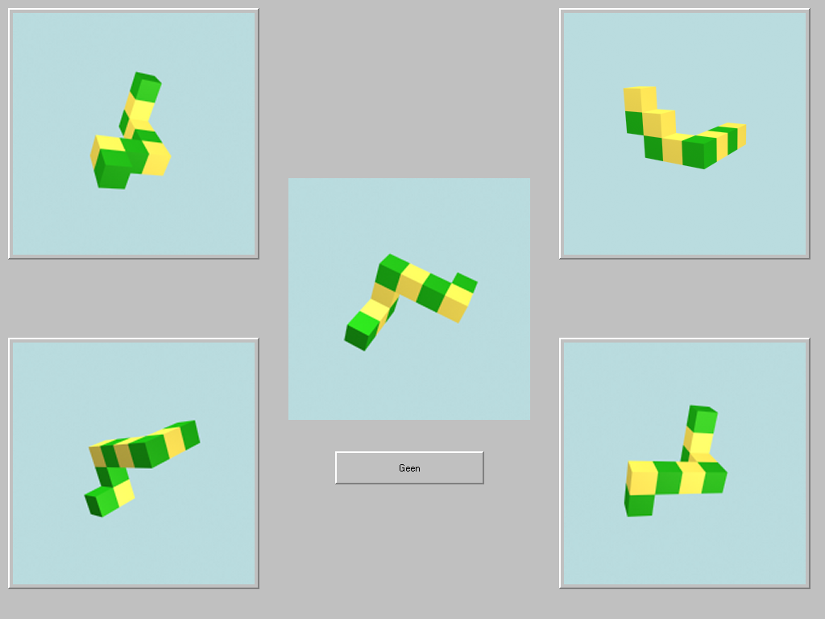
Participants receive a sequence of forty screens (such as shown in Figure 1) in a fixed (but adjustable) time schedule. A reasonable time (15 seconds) was determined by means of a pilot experiment. Within these 15 seconds, a participant has to determine which of the four peripheral images is identical to the central image (by clicking on the image) or has to decide that no image is identical (by clicking on the ‘geen’ (English: none) button). It is
possible to switch between answers during the 15-second interval. When the subject has not chosen an answer after 12 seconds an alarm beep is given.
Figure 1: The user interface of the spatial ability test.

Figure 2 shows the presentation sequence and timing with phase 0 (new set is shown, all buttons are unselected), phase 1 (wait for user's answer), phase 2 (give warning signal, and wait for the user's answer) and phase 3 (process and log answer). The t indicates the presentation time, currently set at 15 seconds.

Figure 2: Presentation sequence and timing for the spatial ability test.

There are five basic forms, which are shown in figure 3. Each basic form exists in four variations, which were made by moving some of the blocks (i.e. green and yellow cubes) (e.g. the form on the right in figure 5 can be made into an E form by moving the lower-left two blocks to the right). Each variation is available in five orientations. So, in total there are a hundred pictures available. The spatial ability program automatically generates a log-file for each trail.
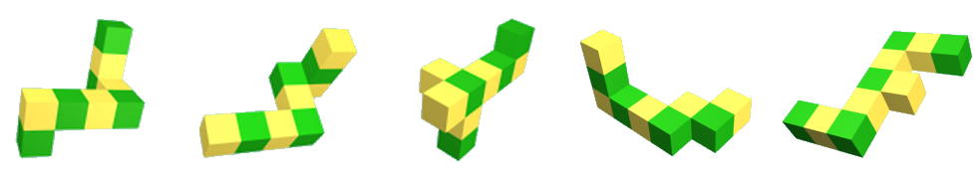
Figure 3: The five basic forms of the spatial ability test.

3. Memory capacity and task-set switching

In complex task situations, people usually don’t just perform one task, with one set of task demands. Complex task situations consist of several different tasks, with different goals, which require adjustments in human behaviour (task strategy). These tasks also appeal to different sources of human knowledge and capacities and refer to different objects in the environment. We use the term task-set to denote the composite of goal, knowledge, capacities and objects (van Besouw, 1999). Switching between task-sets is often required for optimal task management and interleaving is an important aspect of human-computer interaction (Cypher, 1986). However, users are inclined to concentrate on one task-set and neglect another task-set (“cognitive lockup”). Furthermore, switching can be a major mental load factor in itself and elderly seem to have generally less capacity for switching (Kramer et al., 1999; Sit & Fisk, 1999). Kramer et al. (1999) found large age-related differences in switch-costs (i.e. the costs in reaction time and errors due to switching between two tasks) early in practice. However, after relatively modest amounts of practice old and young adults switch costs were equivalent and these age-equivalent switch costs were maintained across a two-month retention period. Memory load turned out to be the main constraint on whether age equivalence was observed in task switching performance. Older adults were unable to capitalise on practice under high memory loads. A similar decrease in overall working memory capacity at times of high demand for elderly was also found for language (Just & Carpenter, 1992).
Next to the performance of multiple tasks in a certain period, people can also perform just one task, which is suddenly interrupted. In general people have cognitive limitations that make them sensitive to interruption. However, there are individual differences in the capacity for handling interruptions.
In sum, task-set switching can be relatively demanding due to an increase in memory load. Individual differences of this effect appear and user interfaces must be designed to accommodate people’s limitations relative to being interrupted (McFarlane, 1999). Card & Henderson (1987) mention two problems that are associated with task switching per se. One is the mental complexity of remembering (i.e. memory load). The second is the amount of time it takes to switch between tasks (cf. switch costs, Rogers & Monsell, 1995). They offer the following properties an interface should possess to accommodate switching behaviour:
- Memory load - access to all relevant information
- fast access to information
- low overhead

- Time - fast task switching
- fast task resumption
- easy to re-acquire mental task context

Within the U-WISH project a spatial memory test was used to assess the different memory capacity of elderly and young people (see box 2). Elderly required more time to finish the task (Neerincx et al., in preparation).

User requirements
Card and Henderson describe the Rooms Design in which they incorporated the above-mentioned set of properties to support task switching. The Rooms Design can be considered to be a specific implementation of a scheduler (e.g. an overview of current not completed tasks). Another type of task-set switching support is goal creation (e.g. someone is making reservations for a musical and the interface suggests to buy the CD of that particular show). Both support types can help users to focus on a new task and, subsequently, to return to the first one. In particular for elderly, positive effects of such support functions on navigation performance can be expected.

Box 2: Memory test

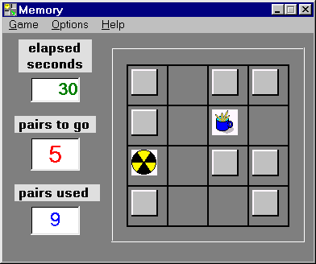
To assess the spatial memory ability of the participants, we searched for a simple memory game on the computer that we could use. In particular because of its simplicity, one 'of the shelf' memory game (figure 4) was selected from a number of candidates. The task of the participants is to find all pairs in a 4 × 4 grid. They are able to select and see a pair of cards each turn. When the pair is identical it will disappear from the grid and when it is not, both cards will be turned around again. When all cards are eliminated from the grid the task is finished. The total number of pairs used to finish the task will be scored in combination with the total time needed.

Figure 4: The user interface of the memory test1.

Whereas this memory test is easy to include in user testing (and might be used to realise an adaptive interface), effects of strategy can not be ignored completely. Other memory tests are being explored, in particular with respect to task-set switching (cf. Rogers & Monsell, 1995) and linguistic memory (cf. the reading span test by Daneman & Carpenter, 1980).

4. Situation awareness

Situation awareness comprises a person’s momentary knowledge of the surroundings and his or her presence in it. This knowledge can be described at three levels: the perception of the elements in the environment within a volume of time and space, the comprehension of their meaning, and the projection of their status in the near future (Endsley, 1995). At the level of perception, an almost infinite number of data and services is spread around the World Wide Web. The content and even its location changes over time continuously. People get lost in information spaces and can suffer from information overload. Errors at the comprehension level result from a lack of understanding of the perceived data in the light of users’ goals. Data are presented most often in one way to a wide variety of users with different domain knowledge and goals, and consequently several user groups can have difficulties in interpreting the content. At the projection level, a fully developed mental model is required for adequate performance. For Web-based services it is particularly difficult to know when to search for new or updated information or products.

Several age-related and disability-related factors determine the success or failure of computer use. Regression of human functions may cause extra problems to learn and use computer-based services.
Age-related perceptual declines will effect people’s situation awareness on the level of perception. On the levels of comprehension and projection most component processes of cognition will have an effect including: attention processes, working memory, information processing speed, inference formation and interpretation, encoding and retrieval processes in memory, and discourse comprehension. Older people have more difficulty acquiring new skills and modifying existing concepts than younger people, and achieve lower levels of performance. Due to diminished processing capacity for example, the visual demands of computer-interactive tasks may be problematic for older people (Czaja, 1997). Charness & Bosman (1992) provide an overview of the age trends that are relevant for software development for the “general public” (see Table I).

Table I: Age trends relevant to Human Factors (Charness & Bosman, 1992)
 |  | MIDDLE AGE (45-64) | OLD AGE (65-74) | LATE OLD AGE (75+)
Perception | Vision | Near focus declining, hence needs reading glasses or bifocals. Increased susceptibility to glare. Less successful dark adaptation. Some decline in static and dynamic visual acuity. Some loss in ability to discriminate colours. | Little focusing ability left, and loss of acuity even with corrective lenses. Less (1/3 compared with young adult) transmission of light through to the retina. Greater susceptibility to glare. Slow dark adaptation. Significant declines in static and dynamic visual acuity, in useful visual field, and colour discrimination ability. | Significant loss of visual acuity (dynamic and static), colour discrimination, and extent of the visual field. Significant risk of visual dysfunction from cataracts, glaucoma, and macular degeneration.
Perception | Hearing | Some loss at high frequencies. | Significant loss at high frequencies and some loss at middle frequencies. Can be helped by hearing aid. Greater susceptibility to masking by noise. | Significant loss at high and middle frequencies. Likely needs a hearing aid.
Comprehension/  Projection | Response Time | Some slowing in response time. | Significant slowing in response time. | Pronounced slowing in response time.
Comprehension/  Projection | Working Memory, Attention | Minor decline in learning ability and ability to divide attention. | Moderate slowing in learning rate and ability to divide attention. | Learning rate is halved from the twenties, and significant declines are observed for dual task performance.
Comprehension/  Projection | Knowledge Base | Little change in fluid intelligence, and stability or increases in crystallised intelligence. | Some decline in fluid intelligence and stability or slight decreases in crystallised intelligence. | Significant declines in fluid and crystallised intelligence.

Within the U-WISH project a categorisation test (see box 3) has been developed for assessing categorisation ability. Elderly proved to perform significantly worse on categorisation than younger participants.

User requirements
NUIs should enhance the perception and comprehension during Web-navigation by fitting the (combinations) of media for information presentation with the current user task, and by displaying information about the current task context. In particular, multi-media enrichment (e.g. text and icon) may reduce the required effort to learn the Web-content and context support (e.g. showing navigation path and header) the effort to interpret the information in terms of the current user goal. Improvements of projection of non-specific or failing goals on near future NUI-states can be realised by goal refinement functions (e.g. to suggest alternatives (with hyperlinks) for non specific goal to for example “go out”: film, theatre, etc. ).

Box 3: Categorisation test

Web-structure
News
Products
Introduction
Facilities
Departments
People
Projects
Request for information
Participants receive a list of eight items (e.g. a subject or a page of the Web-site they haven’t seen before) that were taken from the eight categories that are visible in figure 5. Participants had to indicate in which category they thought a particular item (e.g. a phone number of an employee) could be found.
The participant’s test score was the total number of items that were categorised correctly.

Figure 5: The eight different categories in the categorisation test.

5. Development of navigation support by cognitive engineering

The U-WISH project uses cognitive engineering techniques to develop and test support concepts for NUIs, and to derive HCI guidelines based on the test results. This chapter presents the first concepts that were developed with these techniques: navigation aids that are integrated in the NUI. De Greef & Neerincx (1995) provide a design method in which first an adequate plain interface is realised and subsequently aiding functions are integrated into this interface. These functions complement human knowledge and processing capacities so that the interface at the task level is further adapted to the specific user needs. In the present report, the term adaptation refers to this kind of user interface adjustments.

5.1 Analysis
After our specification of the user requirements mentioned in the previous chapters, Web-design experts of the CWI research institute and the General Design company analysed the navigation support functions that are currently being applied. First, they identified 15 support functions that could be divided in 5 classes, and compared them to the user requirements (Table II). The sitemap is related to most of the user requirements and the agent also covers a lot of them, whereas current directories, search and highlighting are only related to one or two requirements.

Table II. Support functions and user requirements (√= partially addressed).
Support  Function |  | User requirements
 |  | Spatial ability | Task-set switching |  | Situation awareness
 |  | Spatial represent. | Scheduler | Goal creation | Goal refinement | Context support | Multimedia enrichment | Control of support | # of √’s
Task-related | FAQ |  |  | √ | √ |  |  | √ | 3
Task-related | Search |  |  |  | √ |  |  | √ | 2
Task-related | Index |  |  | √ | √ | √ |  | √ | 4
Overview | Sitemap | √ | √ | √ | √ | √ |  | √ | 6
Overview | Splash screen |  |  |  |  | √ | √ | √ | 3
Overview | Guided tour | √ |  | √ | √ |  |  | √ | 4
Overview | History |  | √ |  |  | √ |  | √ | 3
Context cues | Landmarks | √ | √ |  |  | √ | √ |  | 4
Context cues | Curr. directories | √ |  |  |  | √ |  |  | 2
Personali-sing | Highlighting |  |  |  |  | √ |  | √ | 2
Personali-sing | Agents |  | √ | √ | √ | √ |  | √ | 5
Other | Neutral graphics | √ |  |  |  | √ | √ |  | 3
Other | Bookmarks | √ | √ |  |  | √ |  | √ | 4

Second, the goal of the U-WISH project is to develop a theory, guidelines, techniques and tools that allow web-based services to be tailored to changing user profiles and task sets. In order to fulfil this general objective of a web-based service, the adaptations were compared to the following subgoals:
- It should be feasible to expect that the candidate adaptation has a substantial effect.
- The candidate adaptation should be generic enough to be applied to a range of web-based services.
- It should be feasible to expect that the candidate adaptation will be able to assist in the tasks of both novice and expert users.

Table III shows that the positive effects on navigation can be high for the sitemap, landmarks and agents.

Third, there are implementation costs. A support function with an anticipated large effect that is easy to implement should have preference over an adaptation with a small-anticipated effect that is hard to implement.
- Several factors influence the technical complexity: Implementing the support function might call for additional hardware, special software, exclusive plug-ins, or specific Web server configurations.
- If extensive domain knowledge is necessary, or if empirical information needs to be gathered before the support function can be implemented, then the domain complexity is high.
- Some functions by their nature cannot be generated and have to be compiled by hand. Such functions are termed high in editorial complexity. They usually require further editorial investment in the event of the structure of the site changing.
- The scope is the range of different functional approaches covered by the term, this range is one of function and also quality. The smaller the scope the more precise the implementation effort can be estimated.

Table III shows that especially the implementation of the agent is rather complex, mainly due to its broad scope.

Table III. Support functions related to the cognitive engineering objective and cost/benefit
Support  Function | Objective |  |  | Implementation costs
Support  Function | Est. effect | Generic? | Novice/ expert | Techn. complex | Domain complex | Editorial complexity | Scope
FAQ | Medium | No | Both | Low | High | High | Limited
Search | Medium | Yes | Both | High | Low | Low | Wide
Index | Medium | Yes | Both | Low | Low | Medium | Limited
Sitemap | High | Yes | Novice | Medium | Medium | Med/high | Limited
Splash screen | Low | Yes | Novice | Low | Low | Low | Limited
Guided tour | Medium | Yes | Novice | Medium | Low | High | Wide
History | Medium | Yes | Both | Medium | Low | Low | Limited
Landmarks | High | Yes | Both | Low | Low | Medium | Limited
Curr. Directories | Medium | No | Both | Medium | Low | Low | Limited
Highlighting | Low | Yes | Both | High | Low | Low | Wide
Agents | High | Yes | Both | High | High | Medium | Wide
Visited pages | Medium | Yes | Novice | High | Low | Low/med/high | Limited
Chosen routes | Medium | Yes | Expert | Medium | Low | High | Wide
Neutral graphics | Low | Yes | Both | Low | Low | Medium | Wide

Based on the criteria of table II and III, with priority given to the number of user requirements covered and the estimated effects, four sample functions were selected for further investigation: landmarks, history list, sitemap and agent. These functions cover the most user requirements and comply for the main part with the cognitive engineering objective. Only the agent is rather difficult to implement; in particular the scope of this function should be more focussed for implementation.

5.2 Synthesis

After chosen the functions to elaborate on and based on the user requirements, we refined them into three support concepts. In other words, the four existing functions were combined and further developed to address the cognitive factors of navigation performance better resulting in the following promising support concepts:
- The categorising landmarks cover style elements linked to the structure of the site, such as visual landmarks (Vinson, 1999) or musical navigational cues, ‘emons’ (Nemirovsky & Davenport, 1999). Such cues are added to the user interface to support the users in recognising their presence in a certain part of a web-site (i.e. it orders information into categories that are meaningful for the user task). This should help the users to perceive the information in meaningful clusters and prevent them from getting lost.
- The history map is an add-on to a web-based service. The basis for the history map is a sitemap: a graphical representation of the structure of a web site where the layout elements (colour, placement, and size type) indicate how the information is clustered and structured. History information, such as currently provided by Web-browsers (Berkun, 1999), is integrated into the sitemap. This memory aid should improve users’ comprehension of the service’s structure in relation to their task and provide information about the status of their various sub-goals.
- The navigation assistant has knowledge of the domain (the content of the web-based service) and current user (such as interests, profession, education, age and transport constraints). By means of this knowledge the assistant is able to dynamically provide advice to the individual user. This interface concept should help the user to focus on relevant information for the current task.

The map of the support functions on the three levels of situation awareness is rather straightforward (table IV). The landmarks act on the level of perception and should help to categorise the Web-content according to the specific task demands. The history map acts on the level of comprehension and should help to memorise central elements of task performances according to the specific task demands. The assistant acts on the projection level and should help to set the focus on a specific task object according to the specific task demands. These concepts should compensate for the lack in spatial ability or memory capacity.

Table IV: Three support functions for navigation (SA = Situation Awareness).
SA Level | Bottleneck | Remedy | Support
Perception | Information overload and getting lost | Categorise | Categorising landmarks
Comprehension | Task-content mapping | Memorise | History map
Projection | Prediction of interaction outcome | Set focus | Navigation Assistant

Situational determined limitations in users’ “resources” (e.g. time and working memory) constitute another increasingly important challenge to adaptive interfaces (Jameson et al. (1999). “As users carry computers, in various forms, around with them the context of their computing is varied and varying” (Johnson, 1998).

5.3 Example design of support function

A cognitive engineering framework is being applied to design and implement the three support concepts (Neerincx et al., 1999). According to this framework, interface design is a top-down process consisting of two phases that provide the corresponding user interface specification at two levels. In the first phase, based on users’ goals and information needs, the system’s functions and information provision are specified (i.e. the task level of the user interface is established). In the second phase, the control of the functions and the presentation of the information is specified (i.e. the “look-and-feel” or the communication level of the user interface is established). The three support concepts were implemented for two Web-based services that have been under consideration in the U-WISH project: a standard, static web-site ('flat' HTML), and a web site involving a 3D world (based on VRML technology). This section provides a brief overview of the design of a navigation assistant for the first Web-site.

The navigation assistant at the task level
The proposed navigation assistant has knowledge of the domain (the content of the web-based service) and current user (such as interests, profession, current task, education, age and transport constraints). By means of this knowledge the assistant is able to dynamically provide advice to the individual user. The goal of the navigation assistant is to help the user focus on relevant information for the current task.

Figure 6 provides the human-computer co-operation model, describing the joint human-computer execution process and the role of the navigation assistant (De Greef & Neerincx, 1995; Neerincx & De Greef, 1998). Note that this model represents the roles of user and system in the execution process for one cycle. During or after such a process, a new process can be started. The model shows that the user can interact with the content provider, such as a web-server (request(CP)) or the navigation assistant (request(NA)), and that the navigation assistant forwards the last types of requests to the content provider. A request can be an URL-address and the Content Provider provides the response such as a specific Web page. The navigation assistant retains user requests and sets the focus on specific content. The focus is based on the user request history, the profile that users can provide and the domain knowledge of the available content. Several scenarios (i.e. implementations of this model) were specified for the support functions. The next section provides an example storyboard for the navigation assistant.

Figure 6: The joint execution behaviour of three actors: user, content provider and navigation assistant.

The navigation assistant at the communication level
A new browser was installed on the company network of Stefan, a researcher working for a large aircraft manufacturer. When he starts the browser, the navigation assistant asks for user profile information in exchange for improved navigation performance. Stefan is an experienced web surfer but he still looses track once in a while. So, he decides to fill in his profile. First, he provides the assistant with information about himself. Stefan can place restrictions on various items of his profile. In the example Stefan chooses to make his ‘LastName’ only available for services after explicit permission (Figure 7). Stefan also adds information to the profile about his profession: researcher in the aviation domain (Figure 8). Once he finishes filling out his profile he decides to take a look at the web-site of TNO-TM which a friend told him about. The navigation assistant detects that it’s Stefan’s first time on the TNO-TM web-site and tells him that there is a guided tour available (Figure 9). Stefan starts to follow the guided tour, but suddenly
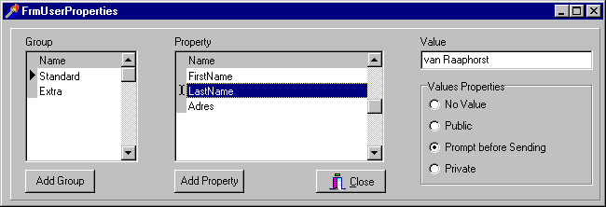
Figure 7: Providing the navigation assistant with his last name.

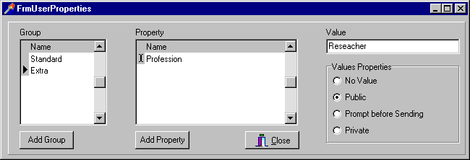
Figure 8: Providing the navigation assistant with his profession.

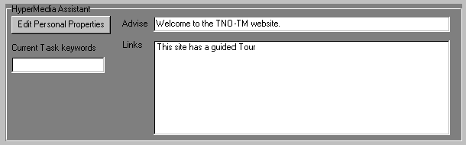
Figure 9: The navigation assistant suggests the guided tour.

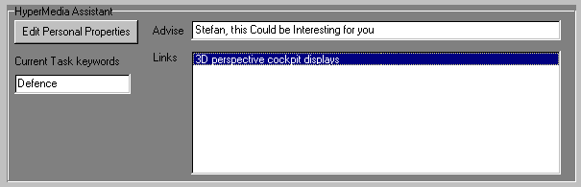
Figure 10: The navigation assistant suggests a relevant project.
he realises that he has an appointment. He finishes the guided tour quickly and turns of his computer. The next day Stefan visits the TNO-TM site again. The assistant detects that it is Stefan and he welcomes him. Stefan is looking for defence related research, so he enters ‘Defence’ as the current task keyword. Stefan searches in the Web-site (“brows”). When he arrives at the Information Processing department, the navigation assistant provides him with a link to information that is especially relevant for Stefan (i.e. researcher in the aviation domain) and his current task (Figure 10). Stefan selects the hyperlink and reads the material on 3D perspective cockpit displays. When he has finished reading, he closes the browser.

Implementation
The navigation assistant provides advice that consists of hyperlinks to information that is relevant for a specific user at a specific state. The current implementation of the navigation assistant consists of two parts: an assistant and a co-assistant (see figure 11). The assistant contains the user profile, the advice history and task-information, and is integrated into the browser. This part also provides the user interface of the navigation assistant. The co-assistant is located on the side of the content provider preferably on the same machine as the web-server. The co-assistant contains domain knowledge about the content of the service, session histories of current and previous users, and a rule base that is able to provide a focus based on this information and the user information gathered from the user profile part of the navigation assistant.

Figure 11: The architecture of the implemented system.

In sum, the navigation assistant provides advice during user's navigation based on knowledge of the user, the current user task and the web content. Whereas the Web-watcher of Joachims et al. (1997) set the focus locally (i.e. within the content of a Web page), the navigation assistant sets the focus onto the content of other pages (and possibly pages of another web-site that has a co-assistant).

6. Discussion and conclusions

The Network User Interface (NUI) provides new possibilities to enhance the accessibility of Web-based services for information or commerce, but also proves to bring about new use problems such as disorientation, laborious navigation and loss of overview. Cognitive engineering theory and methods are needed to integrate human-computer interaction into software development and thus help to reduce such problems. The theory should be the basis of design guidelines and should consist of specification and assessment techniques that address these guidelines at each development stage. The U-WISH project aims at such a method and the present report provides the first results: a practical theory on cognitive determinants of navigation performance, general user requirements for navigation support, a comparison of navigation support functions with these user requirements and the generation three concepts for navigation support: categorising landmarks, history map and navigation assistant. This way we are able to apply cognitive theory and to hook on current NUI developments in the HCI community. Examples of support functions were subsequently developed and implemented using a scenario-based design approach (Carroll, 1995). Specifications of co-operative task performances and scenarios proved to be helpful for envisioning and shaping the support functions.
The support interface intends to improve navigation in Web-environments by general and personalised information provision on situation dynamics. The support functions are generic and can be applied to a broad scope of web-based services. The three support functions could be easily integrated into two different types of Web-sites in terms of concept, since the concepts and design techniques were general enough to allow different implementation solutions.
Next to the development and implementation of support concepts, software tools were developed for the assessment of usability in the U-WISH project. Currently, the support functions are being evaluated with these tools to establish how much they improve usability, to validate the practical theory on navigation performance, to derive design guidelines for navigation support and to improve the support functions. This should result in a Web-based usability handbook for NUI-designers such as the handbook that was developed for designers of payload interfaces for space laboratories (Flensholt et al., 1999). The NUI handbook will structure and refer to current HCI guidelines and techniques using a cognitive engineering framework in which the user interface is specified at two levels. At the task level, based on users’ goals and information needs, the system’s functions and information provision are specified. At the communication level, the control of the functions and the presentation of the information are specified. The handbook’s content will provide the guidelines and techniques that apply to navigation performance in particular and the specification of multi-modal dialogues for complex or error-critical Web-services (Donk et al., 1999). This content is enriched with examples.

Acknowledgements
All partners of the U-WISH project contributed to this paper. Particularly, we would like to mention the activities of General Design: Peter Boersma and Lon Barfield did important work for the analysis, design and implementation of support functions. Stefan van Raaphorst implemented the example navigation assistant of this paper. Further contributions originated from CTIT (Betsy van Dijk, Anton Nijholt, Olaf Donk, Roel Vertegaal and Gerd Spenkelink) and the companies KPN, Océ, Cap Gemini and Rabofacet.

7. References

Berkun, S. (1999). The Explorer Bar: Unifying and Improving Web Navigation. In Sasse, M.A. & Johnson, C. (Eds.) Proceedings of the IFIP TC.13 International Conference on Human-Computer Interaction (Interact’99). Amsterdam, The Netherlands: IOS Press.
Card, S.K. & Henderson Jr., A. (1987). A multiple, virtual-workspace interface to support user task switching. In Carroll, J.M., and Tanner, P.P. (Eds.) Proceedings of the CHI + GI’87 Conference ‘Human Factors in Computing systems –IV and Graphics Interface. Amsterdam: North Holland.
Carroll, J.M. (editor) (1995). Scenario-based design: envisioning work and technology in system development. New York, etc.: Wiley & Sons Inc.
Charness, N. & Bosman, E.A. (1992). Age and human factors. In F.I.M. Craik & T.A. Salthouse (Eds.), The handbook of aging and cognition, (pp 495-551). Hillsdale, NJ: Erlbaum.
Chen, C. & Rada, R. (1996). Interacting with hypertext: a meta-analysis of experimental studies. Human-Computer Interaction, vol. 11, 125-156.
Cypher, A. (1986). The structure of users’ activities. In: Norman, D.A. & Draper, S.W. User-Centered System Design: New Perspectives on human-computer interaction. Hillsdale, N.J. Lawrence Erlbaum.
Czaja, S.J. (1997). Computer technology and the older adult. In: Helander, M.G., Landauer, T.K. & Prabhu, P.V. (eds.), Handbook of Human-Computer Interaction, 2nd edition, Ch 34. Amsterdam: Elsevier North-Holland.
Daneman, M. & Carpenter, P.A. (1980). Individual differences in working memory and reading. Journal of verbal learning and verbal behavior, 19, 450-466.
De Greef, H.P. & Neerincx, M.A. (1995). Cognitive support: designing aiding to supplement human knowledge. International Journal of Human-Computer Studies, 42, 531-571.
Donk, O., Van Dijk, B. & Nijholt, A. (1999). U-WISH: Specification techniques for multi-modal dialogues. (Report No. 99-13). Enschede, The Netherlands: CTIT.
Endsley, M.R. (1995). Toward a theory of situation awareness in dynamic systems. Human Factors, 37, 32–64.
Flensholt, J., Neerincx, M.A., Ruijsendaal, M. & Wolff, M. (1999). A usability engineering method for international space station onboard laptop interfaces. In: T.D. Guyenne (Ed.) Proceedings DAISA Conference (ESA SP-447). Noordwijk, the Netherlands: ESA/ESTEC.
Höök, K., Sjölinder, M. & Dahlbäck, N. (1996). Individual Differences and Navigation in Hypermedia. SICS Research Report, R96:01, SICS, Sweden 1996.
Jameson, A., Schäfer, R., Weis, R., Berthold, A. & Weyrath, T. (1999). Making systems sensitive to the user’s changing resource limitations. Knowledge-Based Systems, 12, 413-425.
Joachims, T., Freitag, D. & Mitchell, T. (1997) WebWatcher: A Tour Guide for the World Wide Web. Proceedings of the IJCAI'97.
Johnson, P., Terveen, L. & Marks, J. (1998) Guest editorial, Knowledge-Based Systems, 11, 1-2.
Just, M.A. & Carpenter, A.C. (1992). A capacity theory of comprehension: individual differences in working memory. Psychological review, vol 99, no. 1, 122-149.
Kramer, A.F. Hahn, S. & Gopher, D. (1999). Task coordination and ageing: explorations of executive control processes in the task switching paradigm. Acta Psychologica, 101, 339-378.
Lindenberg, J. & Neerincx, M.A. (1999). A generic usability test environment for Web-based services. In Pikaar, R.N. (Ed.) Ergonomie in uitvoering: de digitale mens: p38-45. Utrecht: Nederlandse Vereniging voor Ergonomie.
Lohman, D.F. (1979). Spatial Ability: Review and Re-analysis of the Correlational Literature. Stanford University Technical Report 8. Cited in Infield, S., (1991) An Investigation into the Relationship Between Navigation Skill and Spatial Abilities. Doctoral Thesis. University of Washington.
Lohman, D.F. (1980). Individual differences in speed and level in spatial ability. Dissertation Abstracts International, 40(7-A), 3898.
Mayhew, D.J. (1999). The usability engineering lifecycle: a practitioner’s handbook for user interface design. San Francisco: Morgan Kaufman.
Neerincx, M.A. (1998). Design for All: Human Factors of Special Needs in Software Development. (Report TM-98-C068). Soesterberg, The Netherlands: TNO Human Factors Research Institute.
Neerincx, M.A. & De Greef, H.P. (1998). Cognitive support: extending human knowledge and processing capacities. Human-Computer Interaction, 13, 73-106.
Neerincx, M.A. & Lindenberg, J. (1999). Supporting individual situation awareness in web-environments. In Pikaar, R.N. (Ed.) Ergonomie in uitvoering: de digitale mens: p144-155. Utrecht: Nederlandse Vereninging voor Ergonomie.
Neerincx, M.A., Lindenberg, J., Rypkema, J.A. & Van Besouw, N.J.P. (in preparation). UWISH Age differences and navigation support in Web-environments.
Neerincx, M.A., Pemberton, S., & Lindenberg, J. (1999). U-WISH Web usability: methods, guidelines and support interfaces. (Report TM-99-D005). Soesterberg, The Netherlands: TNO Human Factors Research Institute.
Nemirovsky, P. & Davenport, G. (1999). GuideShoes: Navigation based on musical patterns. CHI99 Extended Abstracts (pp. 266-267). New York, NY: ACM.
Newell, A.F. & Gregor, P. (1997). Human Computer Interfaces for people with disabilities. In Helander, M.G., Landauer, T.K. & Prabhu, P.V. (Eds.), Handbook of Human-Computer Interaction, 2nd edition, chapter 35. Amsterdam, The Netherlands: Elsevier North-Holland.
Nielsen, J. (1995). Multimedia and hypertext, the Internet and beyond. Cambridge, MA: Academic Press.
Pellegrino, J.W. & Goldman, S.R. (1983). Developmental and Individual Differences in Verbal and Spatial Reasoning. In R.F. Dillon and R.R. Schmeck, (Eds.) Individual Differences in Cognition, 1, 137-180. NY: Academic Press.
Pellegrino, J.W. & Goldman, S.R. (1990). Cognitive science perspectives on intelligence and learning disabilities. In Swanson H.L. & Keogh, B.K. (Eds.), Learning disabilities: Theoretical and research issues. Hillsdale, NJ: Lawrence Erlbaum.
Ratner, J.A., Grose, E. & Forsythe, C. (1996). Traditional vs. Web style guides: how do they differ? Proc. Human Factors and Ergonomics Society 40th Annual Meeting, 365-369.
Rogers, R.D. & Monsell, S. (1995). Costs of predictable switch between simple cognitive tasks. Journal of experimental psychology: General, 124, 2, 207-231.
Sit, R.A. & Fisk, A.D. (1999). Age-related performance in a multiple-task environment. Human Factors, 41(1), 26-34.
Small, A.M. Sr. (1987). Design for older people. In: G. Salvendy (ed.), Handbook of Human Factors, Chapter 4.4. New York: John Wiley & Sons.
Sutcliffe, A.G. (1995). Human-computer interface design, 2nd edition. London, etc: MacMillan Press Ltd.
Van Besouw, N.J.P. (1999). Cognitive task load: a function of three behavioural variables. Master’s thesis, unpublished.
Vanderheiden, G.C. (1997). Design for people with functional limitations resulting from disability, ageing, or circumstance. In: G. Salvendy (ed.), Handbook of Human Factors and Ergonomics, 2nd edition, Chapter 60. New York: John Wiley & Sons.
Vicente, K.J., Hayes, B.C. & Willeges, R.C. (1987). Assaying and isolating individual-differences in searching a hierarchical file system. Human-Factors, 29(3), 349-359.
Vinson, N.G. (1999). Design guidelines for landmarks to support navigation in virtual environments. CHI99 Conference Proceedings (pp. 278-285). New York, NY: ACM.
Vora, P. (1998). Human factors methodology for designing web sites. In: Forsythe, C, Grose, E. & Ratner, J. (Eds.) Human factors and web development (pp. 153-172). Mahwah, NJ: Lawrence Erlbaum.

Memory, version 1.2 by Bommel.
1

